## 报文

[127.0.0.1:8084/EP_Server/IEPService?wsdl](http://127.0.0.1:8084/EP_Server/IEPService?wsdl)

## 接口样例

<soapenv: Envelopexmlns: soapenv="http://schemas.xmlsoap.org/soap/envelope/"xmlns: ifc="http://ifc.ep.ws.mes.autosuite.rockwell.com"><soapenv: Header/><soapenv: Body><ifc: receiveExactlyBindingData><ifc: in0>[

{

"vin": "LJXCU2BB3MTF00318",

"station": "WBS",

"step_name": "ZHSX_组合锁芯",

"operation_name": "ZHSX_组合锁芯",

"barcode": "SXZC/LS-F02A10P01/JSI-V22050-BB/105443/20201218F1409/",

"part_number": "CX743",

"scan_time": "20210101123412121290",

"user_name": "E"

}

]</ifc: in0><ifc: in1>123456</ifc: in1></ifc: receiveExactlyBindingData></soapenv: Body></soapenv: Envelope>

## 查询表

### Ep_MES

select * from at_as_im_exactlybinding where 1=1 and vin_S ='LJXCU2BB3MTF00318' order by last_modified_time desc;

### MES_ERP

select * from at_as_im_erpkeypart where 1= 1 and vin_S ='LJXCU2BB3MTF00318' order by last_modified_time desc;

## 删除jeiTask中总装站点过点生成MES发送关键件信息给sap的方法generateErpKeyPart

## 将新的接口jar包打入生产环境

## 重启epsos

## 测试url是否可以连接成功

## 去掉生产环境中过点生成关键件信息数据generateErpKeyPart

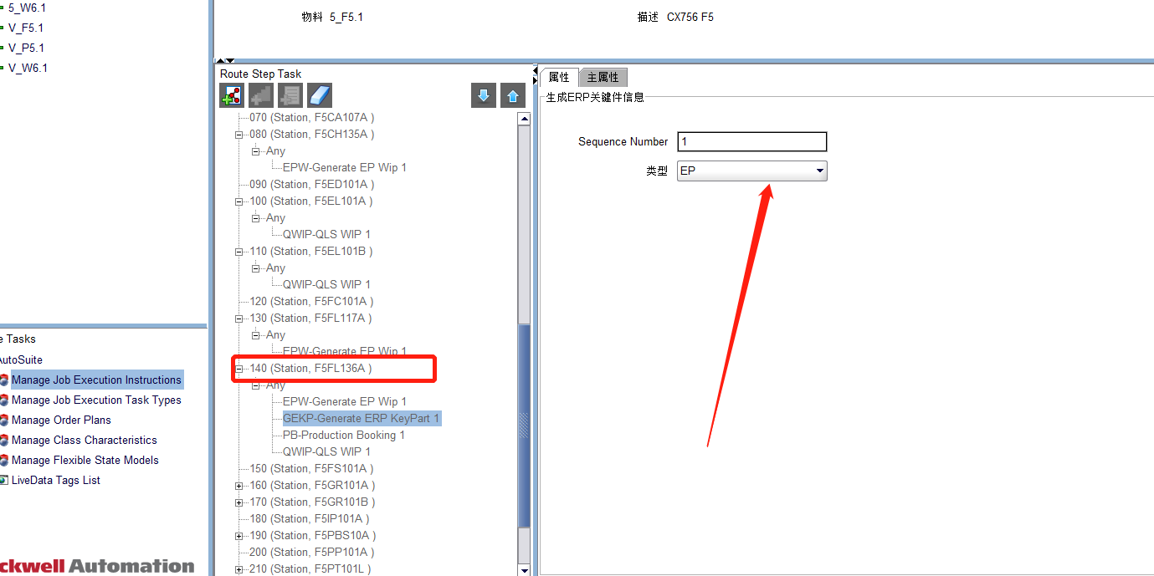

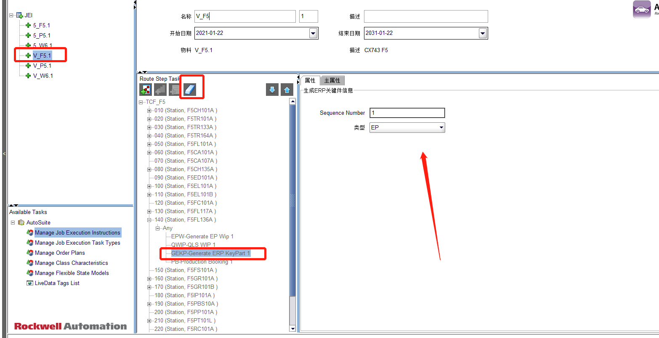

## 重启生产环境中总装的sos

10.27.2.116 主

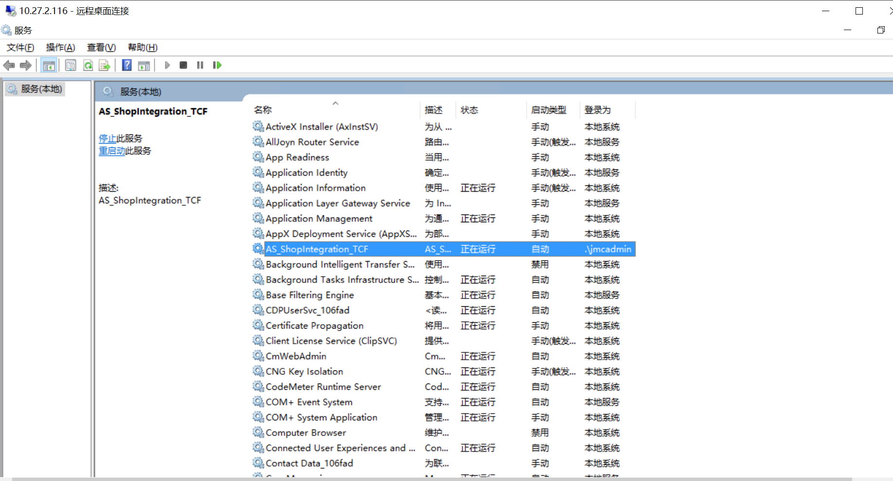

备10.27.2.75

